Example of a greater mIoU but with no loss decrease, meaning we’re good just because the previous model was  
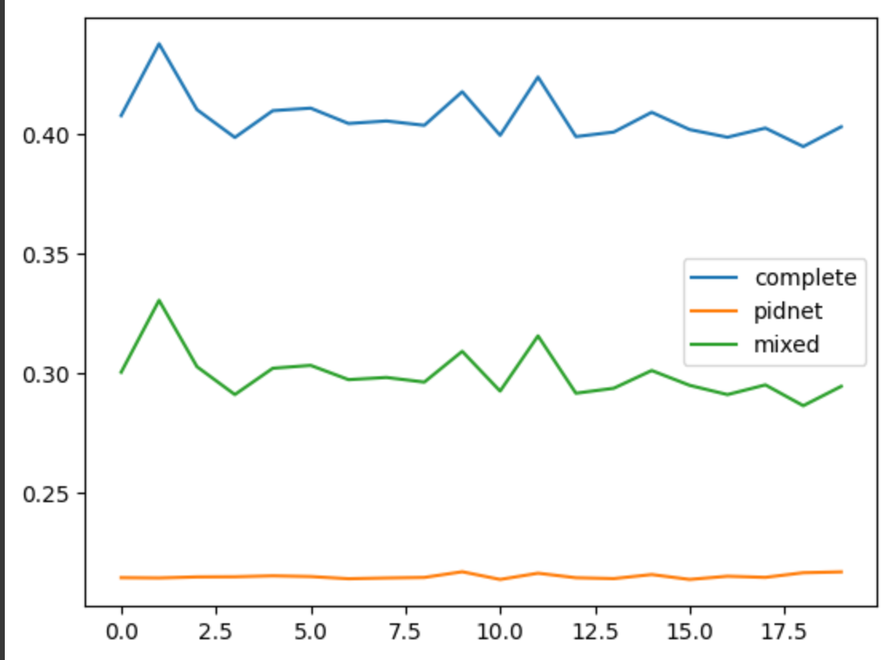

Testing model=best_DACS_model_Resize512__PRETRN=Truebest_model_PIDNET_Jitter+RotateFlip+Resize.pth__LAMBDA_MIXED=18__LR=1e-06_LRstep=21_pxlwtd=Hard__clswtd=False__DETACH_PSEUDO_MASKS=True__ema=True_alpha=0.99__BldngsRoads=Soft@epch16.pth on domain=Rural on a ActualTest split, with ignoring unclassified class to False

Latency: 0.0231 seconds

FLOPs: 12682936320

Total number of parameters: 7717839

100%|██████████| 31/31 [00:27<00:00, 1.11it/s]

Accuracy on the target domain: 52.89%

Background IoU: 0.4766

Building IoU: 0.3005

Road IoU: 0.2580

Water IoU: 0.3547

Barren IoU: 0.0514

Forest IoU: 0.1207

Agricultural IoU: 0.2039

mIoU on the Rural domain: 0.25224339962005615

========================================================================

Dataset size: 677

Testing model=best_DACS_model_Resize512__PRETRN=Truebest_model_PIDNET_Jitter+RotateFlip+Resize.pth__LAMBDA_MIXED=18__LR=1e-06_LRstep=21_pxlwtd=Hard__clswtd=False__DETACH_PSEUDO_MASKS=True__ema=True_alpha=0.99__BldngsRoads=Soft@epch16.pth on domain=Urban on a ActualTest split, with ignoring unclassified class to False

Latency: 0.0229 seconds

FLOPs: 12682936320

Total number of parameters: 7717839

100%|██████████| 21/21 [00:20<00:00, 1.01it/s]

Accuracy on the target domain: 48.47%

Background IoU: 0.2780

Building IoU: 0.4018

Road IoU: 0.4226

Water IoU: 0.4750

Barren IoU: 0.0997

Forest IoU: 0.3559

Agricultural IoU: 0.1807

mIoU on the Urban domain: 0.31625449657440186

========================================================================

Dataset size: 992

Testing model=best_DACS_model_Resize512__PRETRN=Truebest_model_PIDNET_Jitter+RotateFlip+Resize.pth__LAMBDA_MIXED=18__LR=1e-06_LRstep=21_pxlwtd=Hard__clswtd=False__DETACH_PSEUDO_MASKS=True__ema=True_alpha=0.99__BldngsRoads=Soft.pth_20.pth on domain=Rural on a ActualTest split, with ignoring unclassified class to False

Latency: 0.0231 seconds

FLOPs: 12682936320

Total number of parameters: 7717839

100%|██████████| 31/31 [00:27<00:00, 1.14it/s]

Accuracy on the target domain: 52.36%

Background IoU: 0.4755

Building IoU: 0.3013

Road IoU: 0.2526

Water IoU: 0.3432

Barren IoU: 0.0538

Forest IoU: 0.1268

Agricultural IoU: 0.1980

mIoU on the Rural domain: 0.2501814663410187

========================================================================

Dataset size: 677

Testing model=best_DACS_model_Resize512__PRETRN=Truebest_model_PIDNET_Jitter+RotateFlip+Resize.pth__LAMBDA_MIXED=18__LR=1e-06_LRstep=21_pxlwtd=Hard__clswtd=False__DETACH_PSEUDO_MASKS=True__ema=True_alpha=0.99__BldngsRoads=Soft.pth_20.pth on domain=Urban on a ActualTest split, with ignoring unclassified class to False

Latency: 0.0227 seconds

FLOPs: 12682936320

Total number of parameters: 7717839

100%|██████████| 21/21 [00:20<00:00, 1.03it/s]Accuracy on the target domain: 48.35%

Background IoU: 0.2724

Building IoU: 0.3987

Road IoU: 0.4182

Water IoU: 0.4667

Barren IoU: 0.1107

Forest IoU: 0.3493

Agricultural IoU: 0.1926

mIoU on the Urban domain: 0.31551146507263184

========================================================================

While a result that has a decreasing loss, but still doesn’t increase final mIoU is:

<ipython-input-271-c45f6e9ccf7a>:204: FutureWarning: You are using `torch.load` with `weights_only=False` (the current default value), which uses the default pickle module implicitly. It is possible to construct malicious pickle data which will execute arbitrary code during unpickling (See<https://github.com/pytorch/pytorch/blob/main/SECURITY.md#untrusted-models> for more details). In a future release, the default value for `weights_only` will be flipped to `True`. This limits the functions that could be executed during unpickling. Arbitrary objects will no longer be allowed to be loaded via this mode unless they are explicitly allowlisted by the user via `torch.serialization.add_safe_globals`. We recommend you start setting `weights_only=True` for any use case where you don't have full control of the loaded file. Please open an issue on GitHub for any issues related to this experimental feature.

pretrained_dict = torch.load(cfg.MODEL.PRETRAINED, map_location='cpu')

['best_DACS_model_Resize512__PRETRN=Truebest_model_PIDNET_Jitter+RotateFlip+Resize.pth__LAMBDA_MIXED=18__LR=1e-06_LRstep=21_pxlwtd=Hard__clswtd=False__DETACH_PSEUDO_MASKS=True__ema=True_alpha=0.99__BldngsRoads=No@epch14.pth', 'best_DACS_model_Resize512__PRETRN=Truebest_model_PIDNET_Jitter+RotateFlip+Resize.pth__LAMBDA_MIXED=18__LR=1e-06_LRstep=21_pxlwtd=Hard__clswtd=False__DETACH_PSEUDO_MASKS=True__ema=True_alpha=0.99__BldngsRoads=No.pth_20.pth']

Dataset size: 992

Testing model=best_DACS_model_Resize512__PRETRN=Truebest_model_PIDNET_Jitter+RotateFlip+Resize.pth__LAMBDA_MIXED=18__LR=1e-06_LRstep=21_pxlwtd=Hard__clswtd=False__DETACH_PSEUDO_MASKS=True__ema=True_alpha=0.99__BldngsRoads=No@epch14.pth on domain=Rural on a ActualTest split, with ignoring unclassified class to False

Latency: 0.0238 seconds

FLOPs: 12682936320

Total number of parameters: 7717839

100%|██████████| 31/31 [00:27<00:00, 1.11it/s]

Accuracy on the target domain: 53.77%

Background IoU: 0.4804

Building IoU: 0.2800

Road IoU: 0.2589

Water IoU: 0.3023

Barren IoU: 0.0535

Forest IoU: 0.1505

Agricultural IoU: 0.2506

mIoU on the Rural domain: 0.2537429630756378

========================================================================

Dataset size: 677

Testing model=best_DACS_model_Resize512__PRETRN=Truebest_model_PIDNET_Jitter+RotateFlip+Resize.pth__LAMBDA_MIXED=18__LR=1e-06_LRstep=21_pxlwtd=Hard__clswtd=False__DETACH_PSEUDO_MASKS=True__ema=True_alpha=0.99__BldngsRoads=No@epch14.pth on domain=Urban on a ActualTest split, with ignoring unclassified class to False

Latency: 0.0228 seconds

FLOPs: 12682936320

Total number of parameters: 7717839

100%|██████████| 21/21 [00:20<00:00, 1.02it/s]

Accuracy on the target domain: 48.96%

Background IoU: 0.3039

Building IoU: 0.3844

Road IoU: 0.3878

Water IoU: 0.4747

Barren IoU: 0.1066

Forest IoU: 0.3522

Agricultural IoU: 0.2002

mIoU on the Urban domain: 0.31567907333374023

========================================================================

Dataset size: 992

Testing model=best_DACS_model_Resize512__PRETRN=Truebest_model_PIDNET_Jitter+RotateFlip+Resize.pth__LAMBDA_MIXED=18__LR=1e-06_LRstep=21_pxlwtd=Hard__clswtd=False__DETACH_PSEUDO_MASKS=True__ema=True_alpha=0.99__BldngsRoads=No.pth_20.pth on domain=Rural on a ActualTest split, with ignoring unclassified class to False

Latency: 0.0230 seconds

FLOPs: 12682936320

Total number of parameters: 7717839

100%|██████████| 31/31 [00:27<00:00, 1.12it/s]

Accuracy on the target domain: 50.77%

Background IoU: 0.4548

Building IoU: 0.2704

Road IoU: 0.2557

Water IoU: 0.3211

Barren IoU: 0.0520

Forest IoU: 0.1639

Agricultural IoU: 0.2108

mIoU on the Rural domain: 0.24696031212806702

========================================================================

Dataset size: 677

Testing model=best_DACS_model_Resize512__PRETRN=Truebest_model_PIDNET_Jitter+RotateFlip+Resize.pth__LAMBDA_MIXED=18__LR=1e-06_LRstep=21_pxlwtd=Hard__clswtd=False__DETACH_PSEUDO_MASKS=True__ema=True_alpha=0.99__BldngsRoads=No.pth_20.pth on domain=Urban on a ActualTest split, with ignoring unclassified class to False

Latency: 0.0229 seconds

FLOPs: 12682936320

Total number of parameters: 7717839

100%|██████████| 21/21 [00:20<00:00, 1.02it/s]Accuracy on the target domain: 47.62%

Background IoU: 0.2980

Building IoU: 0.3792

Road IoU: 0.3827

Water IoU: 0.4715

Barren IoU: 0.1189

Forest IoU: 0.3536

Agricultural IoU: 0.1451

mIoU on the Urban domain: 0.30700474977493286

========================================================================